**Day 3 Lab Assignments**

**Do the following CSS style for the given HTML page** (run the page and see the result after each point)**:**

1. Make External CSS file for that:
   1. Make the font type "any font type" for any p or div or span tag (use one CSS rule).
   2. <h1> tag child from div tag is in the center of the page.
2. Make inline style for the div with "header" id, that make its width=100%, its height=30%, and its background color red.
3. Make inline style for the span with "linksbar" id, that make its width=25%, its height=70%, its background color gray, and make it starts from the left of the page (float property).
4. Make inline style for the span with "content" id, that make its width=75%, its height=70%, its back color pink, and make it comes to the left side after the previous span (float property).
5. Make internal style that:
   1. Make a class name "none-bullet-list" that can be applied on <ul> tags, and makes list style type of the <ul> without bullets (none), and apply this class on the <ul> tag that contains the links (apply it to the ul tag in html directly, the selector will be class name only).
   2. Make color red, and background color pink for the links that're direct child for <li> tag, which inside span with id= "linksbar", and make it appear without underline (text-decoration property).
   3. Make color pink, and background color red for the links that're direct child for <li> tag, which inside span with id= "linksbar", when mouse is over it.
   4. Make the font weight bold, and font size 12px, for the paragraph that comes directly after (sibling) <h2> tag which is direct child for <span> with id="content".
   5. Make a dashed border, with size 2, and color rgb(20,70,60), for the div with id " loginform".
   6. Make style that makes the background color yellow of the any <input> of type "text", and another style that makes its background color white when it's focused.
   7. Make a class named "tabled-bordered" that can be applied on any tag, and make it displayed as table cells (use display property), its padding 5, and make a border for it. Apply the class to the 3 <p> tags that are in the "titles" div (apply them on the p tags that are in "titles" div in html file, the selector will be class name only).
      1. Try to change the <p> tags inside the div with id "titles" to spans, is there any difference?
6. Make an internal style that makes font color red for the <p> with id "aboutus", and another internal style that makes the color yellow for the <p> with id "aboutus" that's direct child from span with id "content". Which style will be applied to the paragraph? And why?
7. Use !important with the first style of the previous 2 styles. What's the change that happened and why?

The page should be like that after you apply the previous styles:

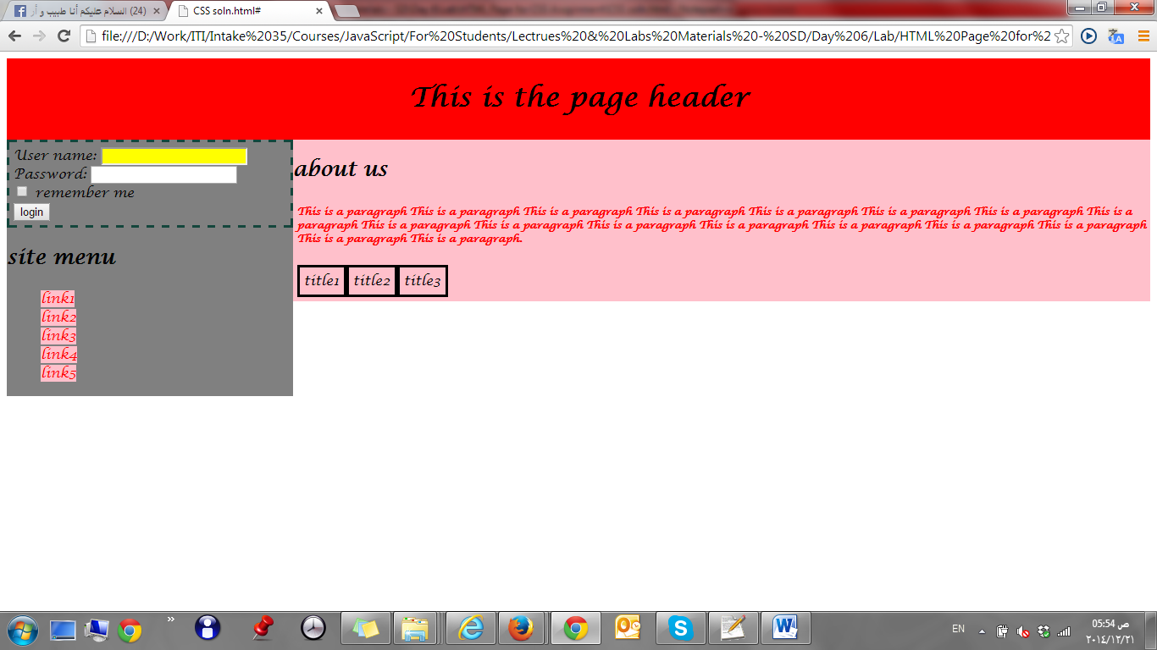

**Bonus:**

1. Calculate the specifity, for the 2 styles in assignment No. 6, in the part 1 assignments.
2. Use CSS to create HTML page that has dropdown menu like:

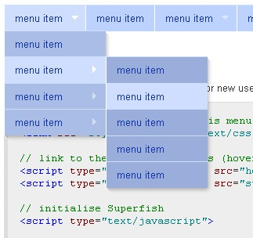

**<Script>document.write(“Thank YOU”) </Script>**